36.71: Diffraction limited seeing and Rayleigh’s criterion tell us:
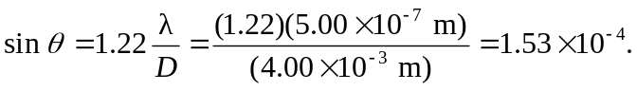
But now the altitude of the astronaut can be calculated from the angle (above) and the object separation (75 m). We have:

